Surgical risk Prediction using Digital Twin Modeling with BioGears

TEAM MEMBERS: CHINTHAN K PES2UG23CS155

DEVRAJ PES2UG23CS167

GANESH PES2UG23CS194

FAVAZ PES2UG23CS190

Simulation Layer (Digital Patient)
Tool: BioGears
Purpose:
Simulates the virtual patient during surgery.
Inputs:
- anesthesia drugs
- oxygen supply
- blood loss
- ventilation settings
scenarios:
- AnesthesiaInduction_Demo
- OxygenTankPressureLoss
- VentilatorPressureLossVaried
Output:
Time-series physiological data:
HeartRate
BloodPressure
OxygenSaturation
RespirationRate
CardiacOutput
Generated as:
CSV physiological data
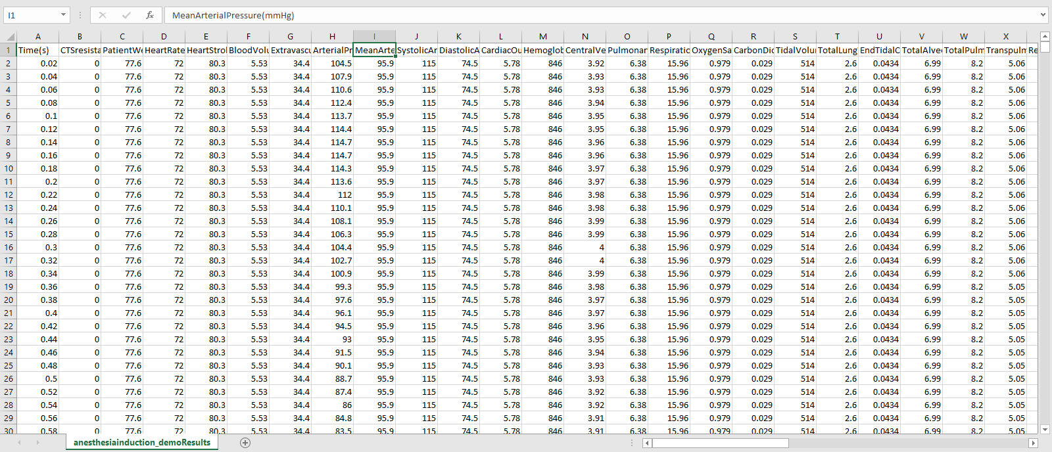

Data Processing Layer
Language: Python
Purpose:
Process simulation output and prepare it for analysis.
Steps:
- Load CSV
- Clean data
- Normalize signals
- Extract features
Example signals:
Time | HR | MAP | O2Sat
0 | 72 | 95 | 0.98
60 | 80 | 90 | 0.95
Libraries:
- pandas
- numpy
- matplotlib

Prediction Layer (AI Model)
Models you can use:
- Random Forest
- XGBoost
- LSTM (time series)
Goal:
Predict surgical risks such as:
- hypoxia
- blood pressure drop
- cardiac instability
Example prediction:
Hypoxia risk: 0.76
BP instability risk: 0.42

Backend API Layer
Framework: FastAPI
Purpose:
Connect AI model → web visualization.
Functions:
GET /patient-data
GET /prediction
Returns:
JSON physiological signals
Example:
{
"heart_rate": 78,
"oxygen_saturation": 0.94,
"risk_score": 0.71
}

Visualization Layer (Digital Twin UI)
Tool: Three.js
Purpose:
Show interactive digital twin of the patient.
Visual elements:
3D patient body
Color changes based on risk:
Condition | Color
Normal | Green
Oxygen drop | Yellow
Critical | Red
Real-time graphs:
- heart rate
- oxygen saturation
- blood pressure
